Testing and Logging - Completion Report

JUnit Exercise 1: Setting Up JUnit

File: pom.xml
<project xmlns="http://maven.apache.org/POM/4.0.0"
xmlns:xsi="http://www.w3.org/2001/XMLSchema-instance"
xsi:schemaLocation="http://maven.apache.org/POM/4.0.0 http://maven.apache.org/xsd/maven-4.0.0.xsd">
<modelVersion>4.0.0</modelVersion>
<groupId>com.cognizant.fse</groupId>
<artifactId>testing-logging-exercises</artifactId>
<version>1.0-SNAPSHOT</version>
<properties>
<maven.compiler.source>17</maven.compiler.source>
<maven.compiler.target>17</maven.compiler.target>
</properties>
<dependencies>
<dependency>
<groupId>org.junit.jupiter</groupId>
<artifactId>junit-jupiter</artifactId>
<version>5.10.0</version>
<scope>test</scope>
</dependency>
<dependency>
<groupId>org.mockito</groupId>
<artifactId>mockito-core</artifactId>
<version>5.5.0</version>
<scope>test</scope>
</dependency>
<dependency>
<groupId>org.mockito</groupId>
<artifactId>mockito-junit-jupiter</artifactId>
<version>5.5.0</version>
<scope>test</scope>
</dependency>
<dependency>
<groupId>org.slf4j</groupId>
<artifactId>slf4j-api</artifactId>
<version>2.0.9</version>
</dependency>
<dependency>
<groupId>ch.qos.logback</groupId>
<artifactId>logback-classic</artifactId>
<version>1.4.11</version>
</dependency>
</dependencies>
</project>

Proof of Execution
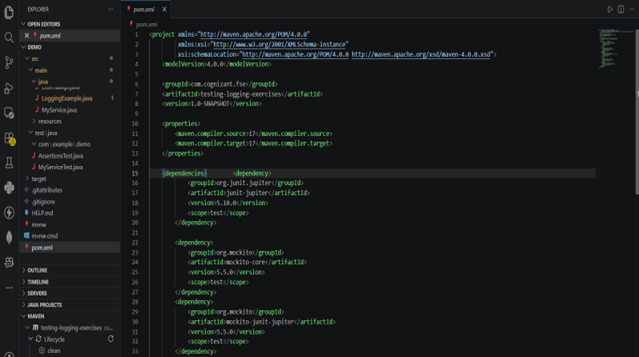

JUnit Exercise 3: Assertions in JUnit

File: AssertionsTest.java
@Test
void testAssertionsAndAAA() {
// Arrange
String expectedValue = "Cognizant";
String actualValue = "Cognizant";
int[] expectedArray = {1, 2, 3};
int[] actualArray = {1, 2, 3};
// Act & Assert
assertEquals(expectedValue, actualValue, "Strings should be equal");
assertNotEquals("Java", actualValue, "Strings should not match");
assertTrue(5 > 3, "Condition should be true");
assertFalse(3 > 5, "Condition should be false");
assertNull(null, "Object should be null");
assertNotNull(actualValue, "Object should not be null");
assertArrayEquals(expectedArray, actualArray, "Arrays should match exactly");
}

Proof of Execution
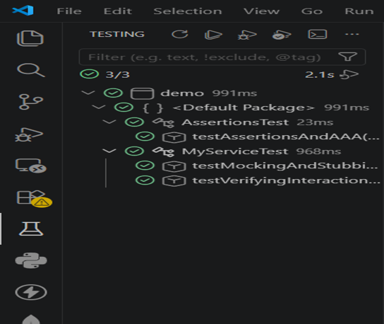

JUnit Exercise 4: AAA Pattern, Fixtures, Setup & Teardown

File: AssertionsTest.java
@BeforeAll
static void setupAll() { System.out.println("Test Fixture: Running once before all tests"); }
@BeforeEach
void setUp() { System.out.println("Test Fixture: Setting up before each test"); }
@AfterEach
void tearDown() { System.out.println("Test Fixture: Tearing down after each test"); }
@AfterAll
static void tearDownAll() { System.out.println("Test Fixture: Running once after all tests"); }

Proof of Execution
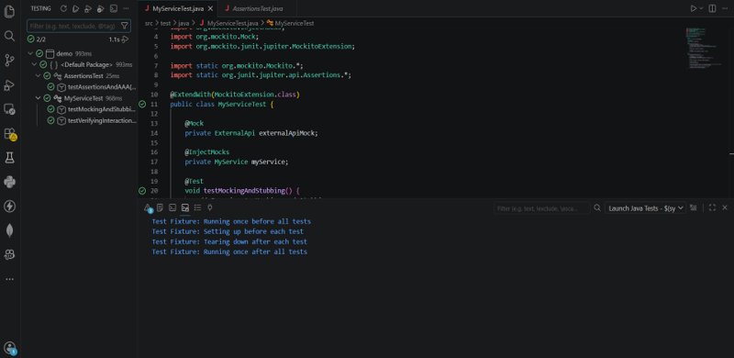

Mockito Exercise 1: Mocking and Stubbing

File: MyServiceTest.java
@Test
void testMockingAndStubbing() {
// Arrange: Stub the mock to return a specific value
when(externalApiMock.getData()).thenReturn("Mocked Database Response");
// Act
String result = myService.fetchData();
// Assert
assertEquals("Mocked Database Response", result);
}

Proof of Execution
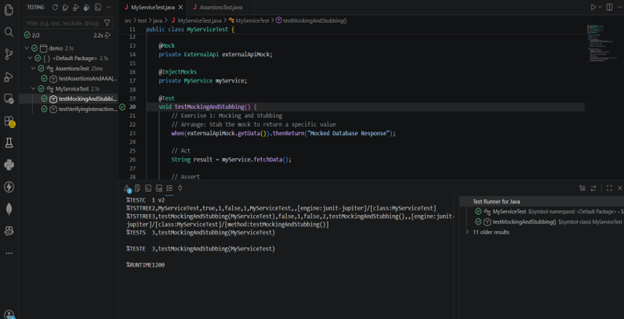

Mockito Exercise 2: Verifying Interactions

File: MyServiceTest.java
@Test
void testVerifyingInteractions() {
// Arrange
String inputData = "Test Payload";
when(externalApiMock.processData(inputData)).thenReturn(true);
// Act
boolean isProcessed = myService.sendData(inputData);
// Assert & Verify
assertTrue(isProcessed);
// Verify that the external API was called exactly once with the specific parameter
verify(externalApiMock, times(1)).processData(inputData);
// Verify no other methods were called on this mock
verifyNoMoreInteractions(externalApiMock);
}

Proof of Execution
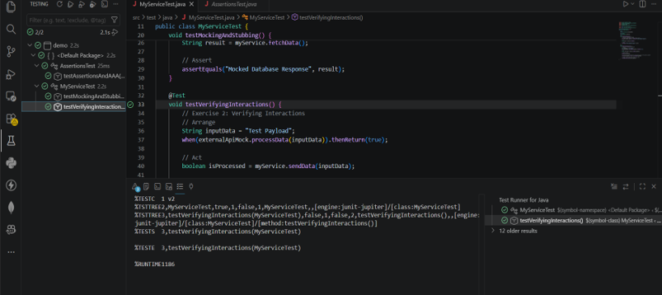

SLF4J Exercise 1: Logging Error Messages and Warning Levels

File: LoggingExample.java
public static void main(String[] args) {
// Exercise 1: Logging Error Messages and Warning Levels
logger.warn("This is a WARNING level message: Application memory is running low.");
try {
int result = 10 / 0;
} catch (ArithmeticException e) {
logger.error("This is an ERROR level message: Arithmetic exception occurred.", e);
}
logger.info("Application execution completed.");
}

Proof of Execution
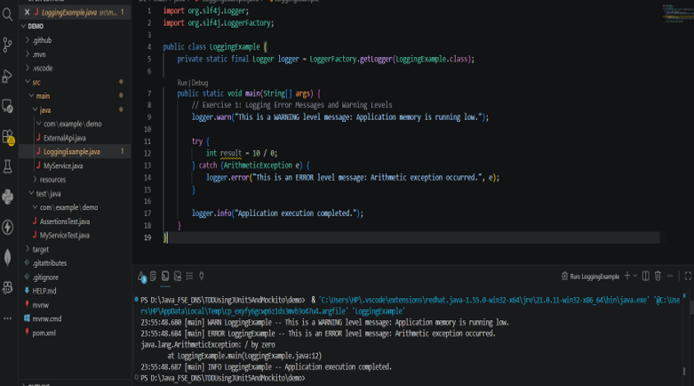

Final Verification: Maven Lifecycle
Run "mvn clean test" in the terminal to verify the entire build.

Proof of Build Success
